**Data analysis Exercises**

**Exercise 1** 4x5 =20

**Question 1**

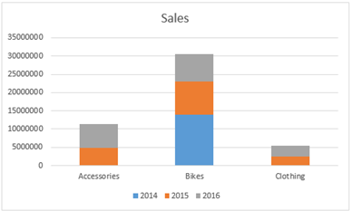

Choose any one of the following:

You are asked to display a trend for each product by year. What should you do?

1. Modify the chart to have the product categories as Legend and years as horizontal axis

**Question 2**

You have collected the following data and are considering using a pie chart to display it.

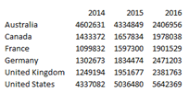

Choose any one of the following:

What is a problem that you are likely to encounter by using a pie chart?

1. The pie chart will only show one of the year’s data.

**Question 3**

You have collected the following data and want to use a chart to display it.



Which chart should you use to display it?

1. Line chart

**Question 4**

You have a pivot that is based on an Excel table. You need to add new rows to the Excel table and want to be able to see the values for these new rows in the PivotTable. What should you do?

1. Add rows anywhere in the table, and refresh the pivot table.

**Exercise 2** 2x10=20

Use *Sales* worksheet for this exercise.

The first thing you need to do is to convert the data into an Excel table.

Once you do that, you can add total row, filter the data, and the total will reflect the total only for the filtered data. Add a total row for the table,and use the Sum aggregation to show the total of the **Revenue** column and then filter the data only for **United States**.

**Question 1**

What is the total revenue for all the sales in the **United States**? (10)

1. 27975547

**Question 2**

What is the total revenue for all the sales in the month of **December**? (10)

1. 9086931

**Exercise 3** **2x10=20**

Use *Sales* worksheet to answer the questions below.

Name the Excel table prepared in the previous lab to **SalesTable**.

Insert a new pivot table based on the SalesTable to a new sheet. Arrange the layout so that the pivot table displays the **Product Category** and **Sub Category** in the **Rows**, **Year** in the **Columns**, and **Revenue** (Sum of) as the **Values**.

**Question 1**

Which year did the company start selling **Touring Bikes**?

1. 2013

**Question 2**

Which age group has the lowest revenue?

1. Seniors

**Exercise 4** **40**

Use Mall_customers worksheet to do the following:

Create an interactive Dashboard to show

1.Spending score by age

2.Spending score by annual income